Moving WIP to Billed

1. Locate WIP Invoice(s)
- In QuickBooks, go to Advanced Search.
- Search by P.O. Number (the P.O. Number is the Work Order).
- Take a Snippet of all WIP invoices listed in the search screen.
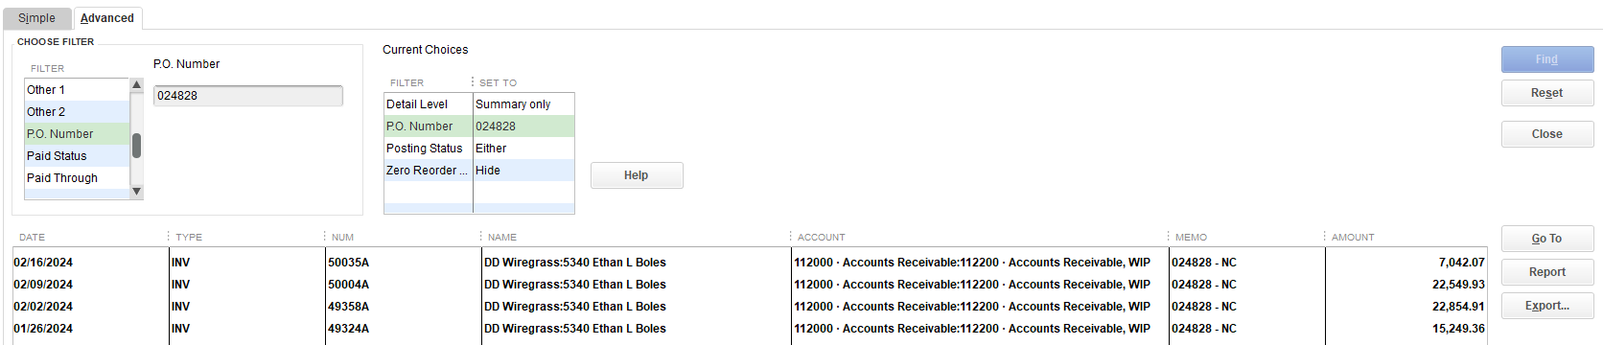
2. Create Credit Memo
- Select the WIP invoice.
- Choose Refund/Credit.
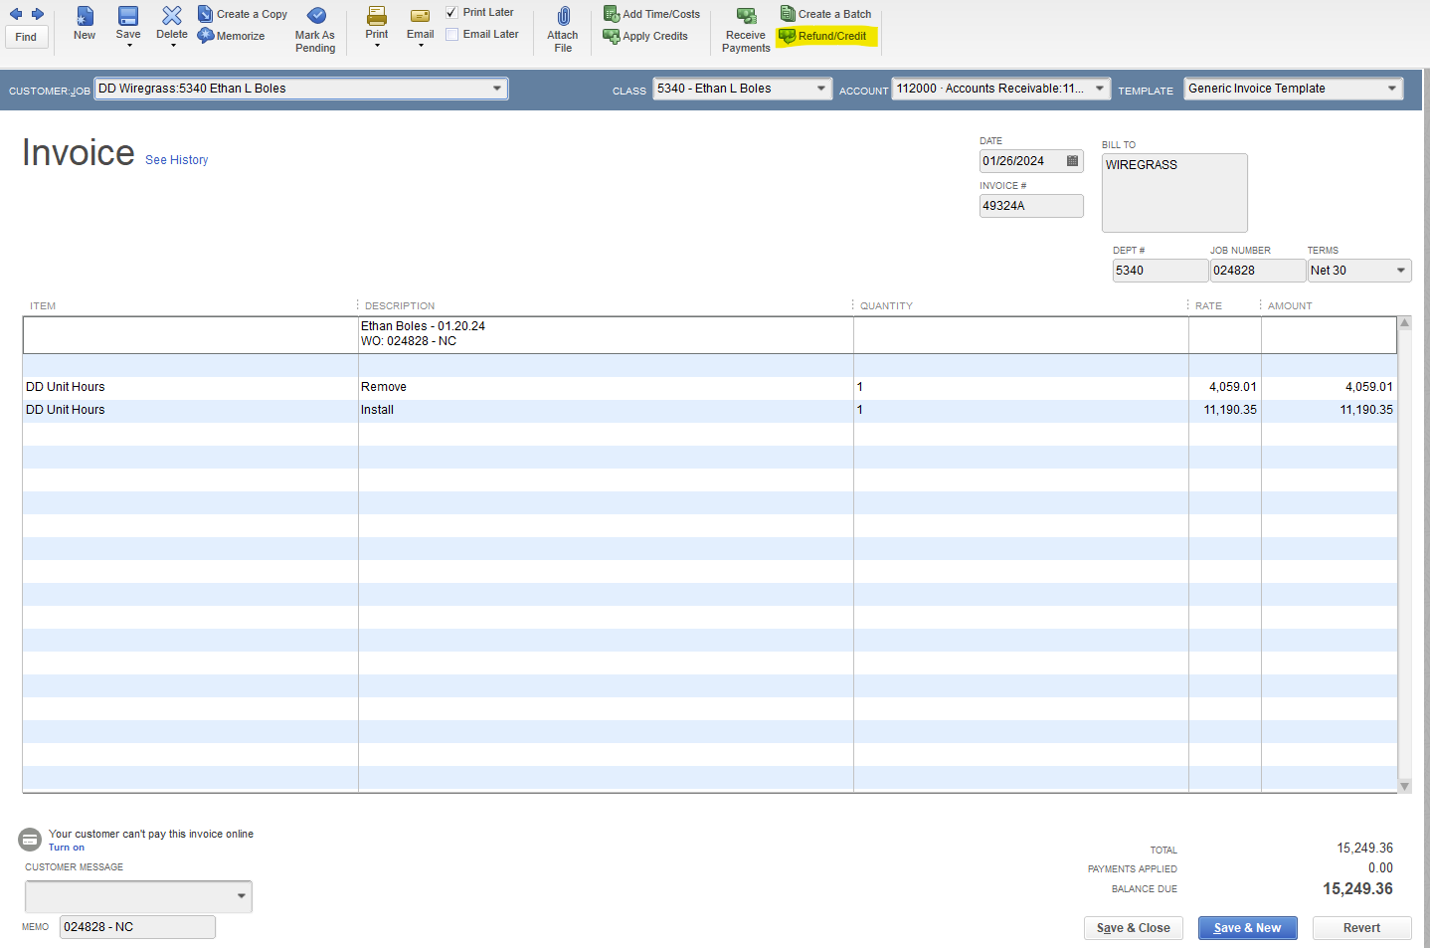
- Verify:
  - Customer Job
  - Class
- Date: Use the Thursday of the current week.
- Credit Memo number format:
  - Add W = move to billed
  - Add CM = write-off
- Enter the total of the WIP invoices:
  - W Credit Memo total = amount moving to billed
  - CM Credit Memo total = amount being written off
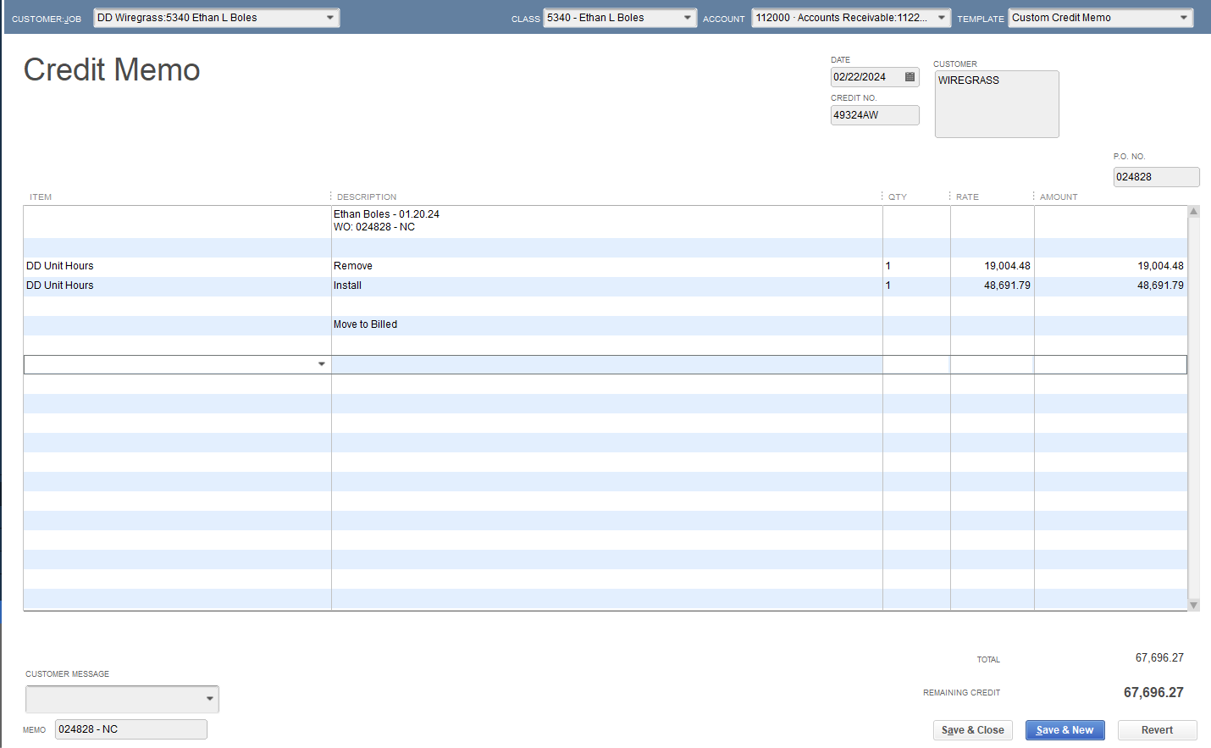

- Ensure the Account matches the invoices that the credit will be applied to.
Important: If a credit memo is created in the wrong account, edit it to the correct account. Do not create multiple credit memos.

3. Apply Credit Memo
- Choose Save & Close.
- Apply the credit memo to an invoice.
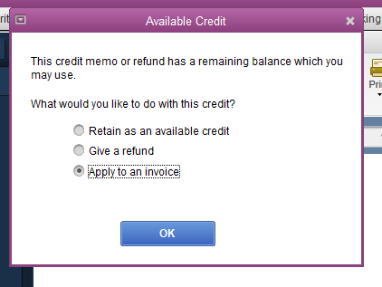
- Select the WIP invoices to be credited out.
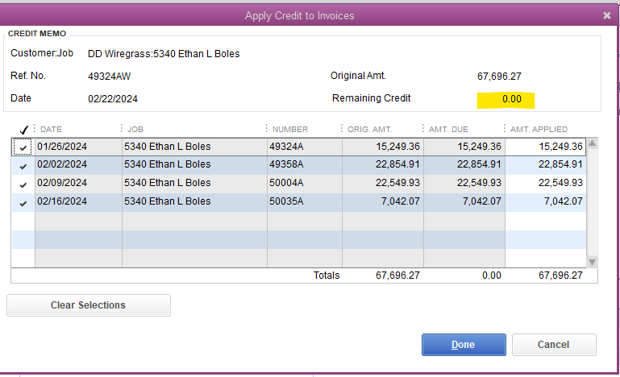
- Verify:
  - Invoice Number is correct
  - Amount is correct
  - Remaining Credit = $0.00
4. Verify WIP Balance
- Confirm all WIP invoices now show a $0 balance.
5. Create Billed Invoice
- Create a copy of the WIP invoice.
- Verify:
  - Account = Billed
  - Date matches the Credit Memo date
  - Invoice Number = WIP invoice number without the “A”
- Edit invoice header
- Change Memo to BILLED
- Edit invoice lines so totals match your final billing.
- Save Billed Invoice
- Use Adobe to combine billed invoice with all supporting documents.
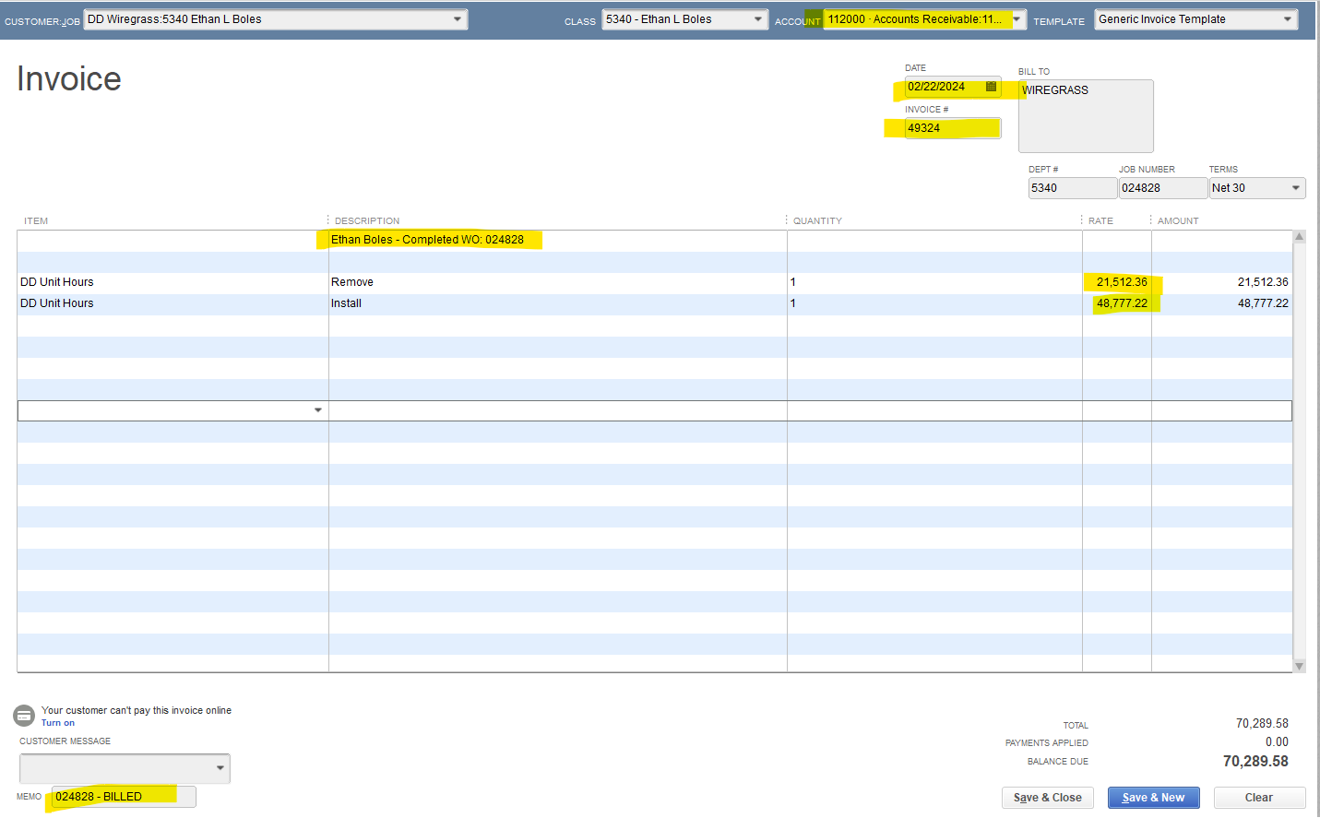
7. Track Adjustments
- Add all write-ups / write-downs to the WUWD sheet.
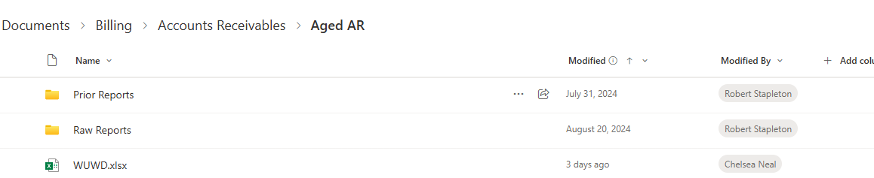
8. Final Review
- Review all QuickBooks entries for accuracy before submitting invoices to your lead for approval.
  - Examples:
- Write Up (Only one credit memo, you will see the write up amount in the difference between the CM and the Billed invoice)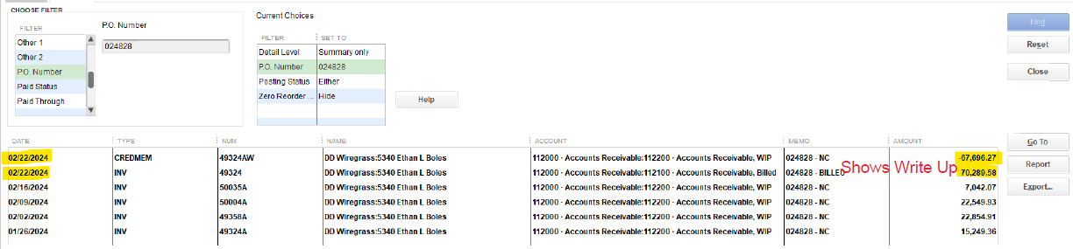
- Write Off (Two credit memos, your two credit memos should equal the total amount you had in WIP)
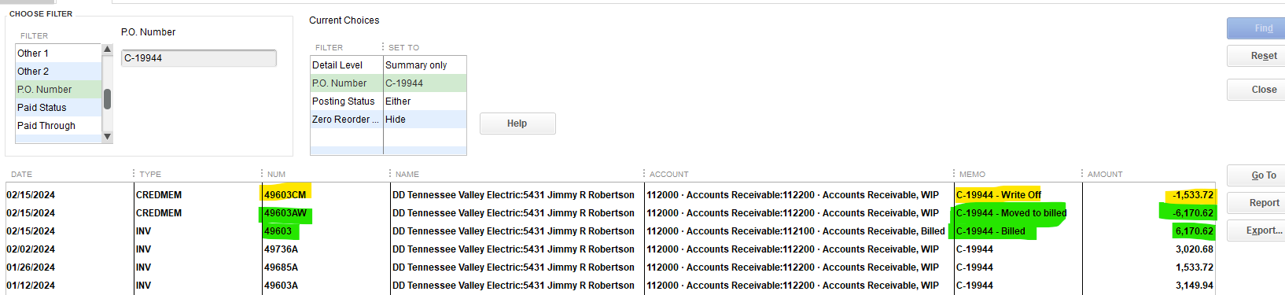

Write-Offs
Scenario: You have a WIP invoice for $10,000 but will bill the customer $9,500.
- Create:
  - $9,500 Credit Memo with W → 12345AW
  - $500 Credit Memo with CM → 12345ACM
- Use the WIP invoice number without the “A” for the billed invoice (e.g., 12345).
- The total of both credit memos should equal the total WIP amount.
- Confirm there is no remaining balance for the Work Order in WIP.

Write-up
Scenario: You have a WIP invoice for $10,000 but will bill the customer $10,500.
- Create:
  - $10,000 Credit Memo with W → 12345AW

- Use the WIP invoice number without the “A” for the billed invoice (e.g., 12345).

- Confirm there is no remaining balance for the Work Order in WIP.

- The billed invoice will show the write-up.



